13 MARCH 2022

JAVA CRASH COURSE

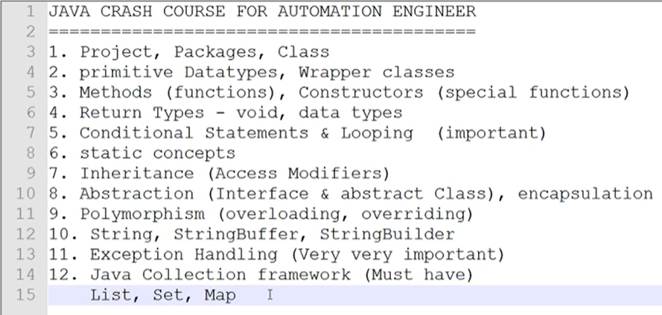

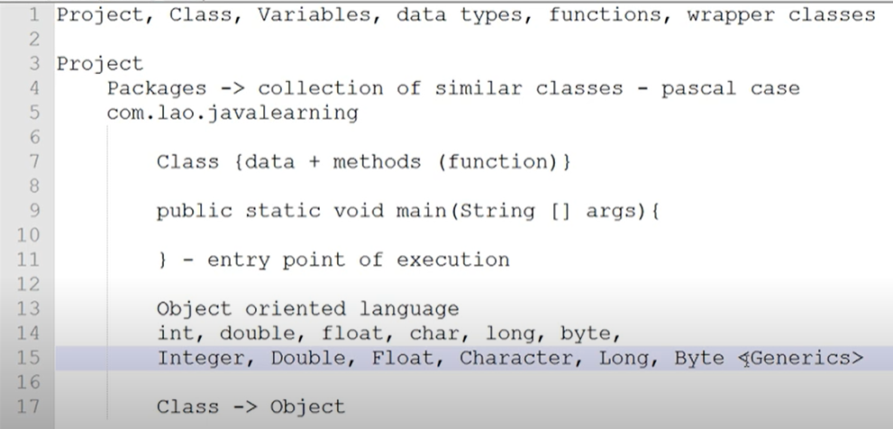

The reason why main is the first method that is being called –

JVM (Java Virtual Machine) needs an entry point of execution like how someone needs to enter their house through the door. You cannot enter into the house without the door. Similarly, JVM needs a point of entry, which is the main method.

OOPS – Java is an Object Oriented Programming Language

People started to question if Java was really an OOPL since it still used the primitive data types mentioned in the above image. Objects can only be created for classes (Objects are an instance of the class) and not for data types.

To resolve this issue, Java came up with the concept of Wrapper Classes. They basically created Classes for each primitive data types using which we can perform all the funtions of the primitive data type.

CONSTRUCTOR

Constructor name must be the same as Class name

Constructor does not have a return type

It cannot be abstract, final, static and synchronized

Constructor is a block of code that initializes the newly created code. A new object is created when new keyword is used.

We have default, No Arguments and Parameterized Constructors.

Default constructors is not user added, it will be automatically provided by the complier. It initializes default values to objects, data types, etc.

String test;

ClassName obj = new ClassName();

System.out.println(obj.test);

Console will print null. Value for test was assigned as null because it was initialized by the constructor during code execution.

**ClassName obj – Creating an object called obj for Class ClassName**

**= is used to assign the RHS value to the LHS object**

**New is used to initialize the object**

**ClassName() is the default invisible constructor**

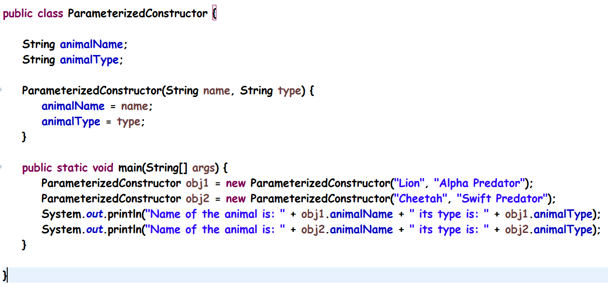

OR

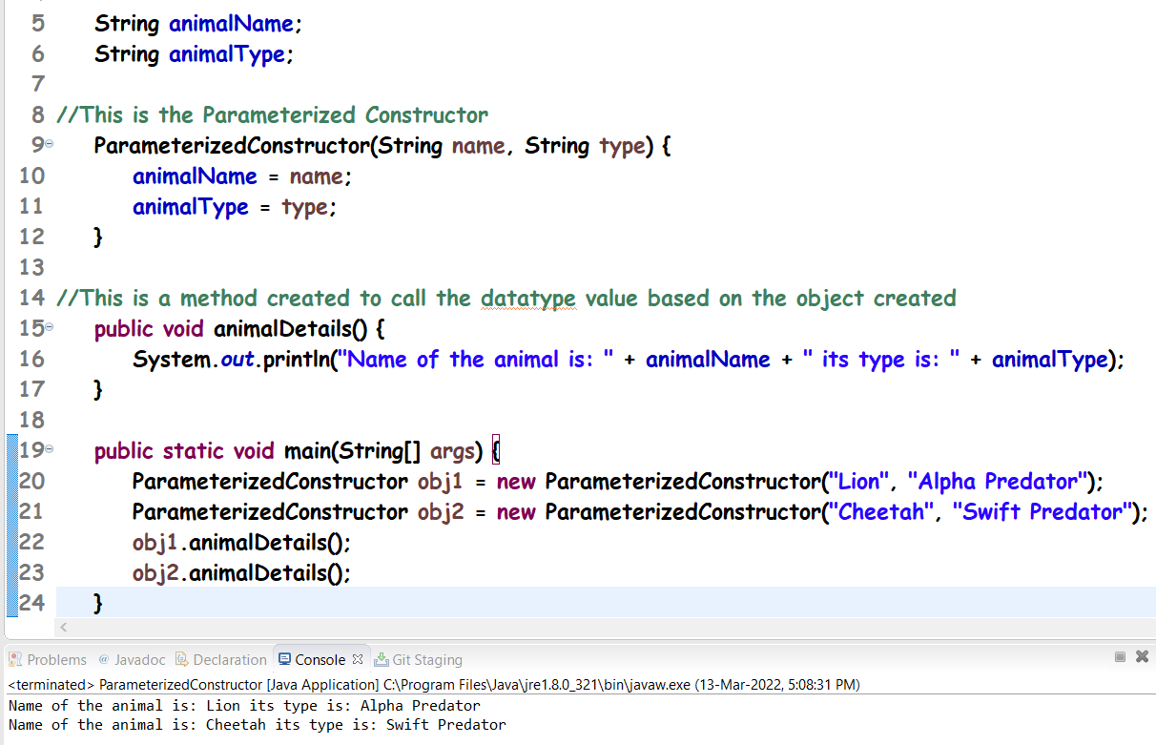

Constructor Overloading:

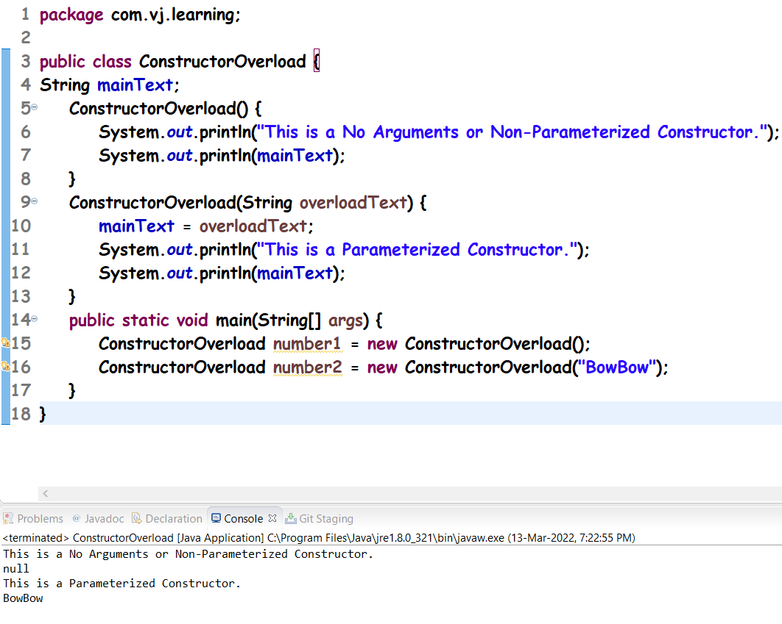

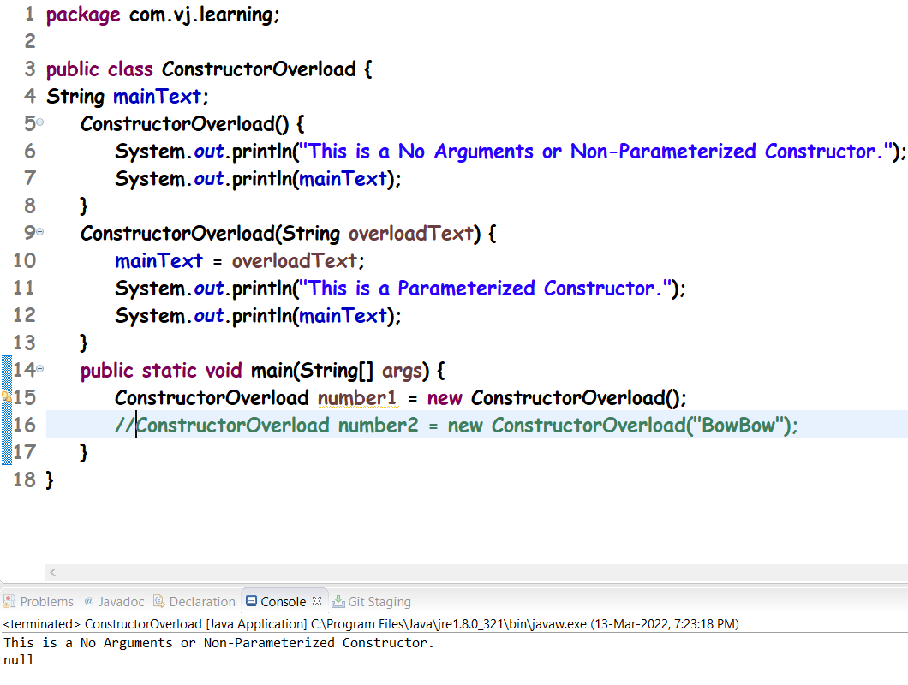

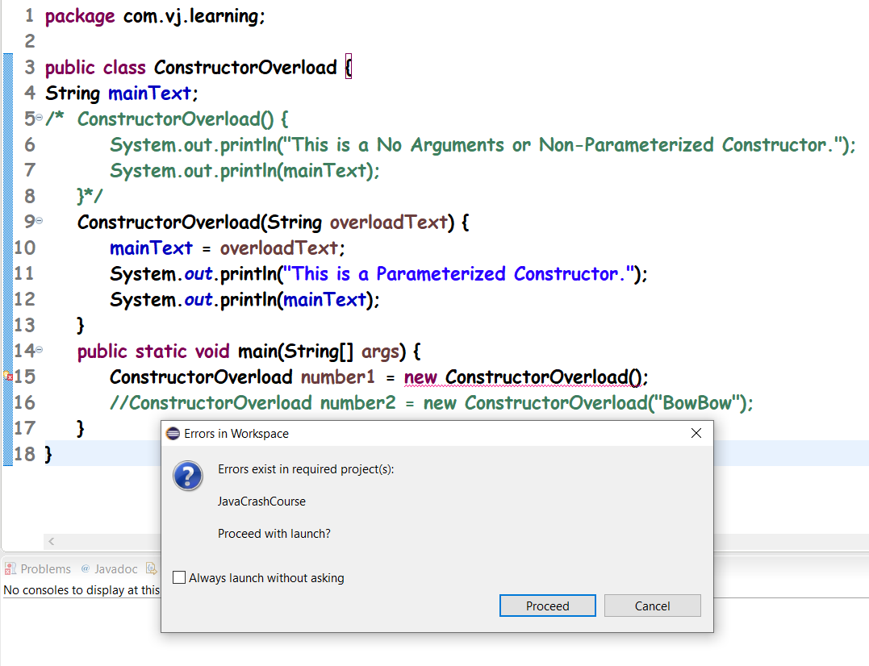

Keywords this and super:

Both keywords are mainly used in constructors. This will refer to the current class and super will refer to the main class.

When we create an object for the Child Class, it can be seen that the constructor of the Parent class is called first and then the constructor of the Child class is called. Check below image:

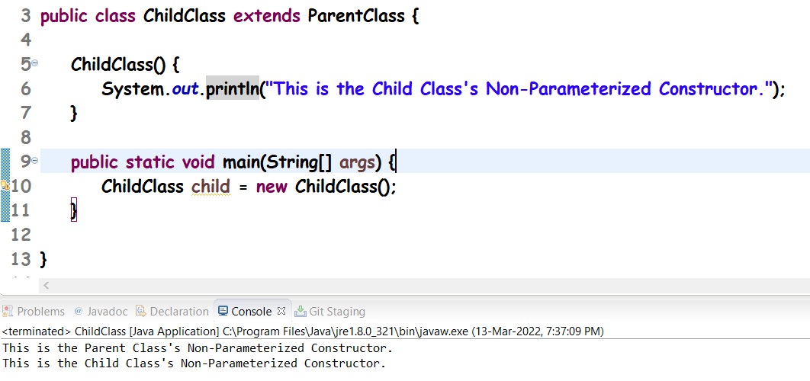

The above happens because there is an invisible super(); inside the Child class’ Non-Parameterized Constructor:

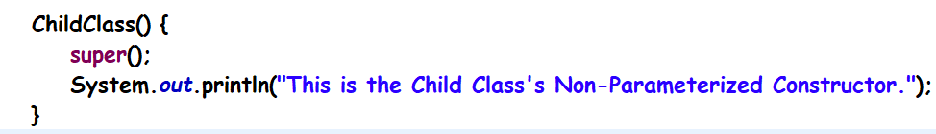

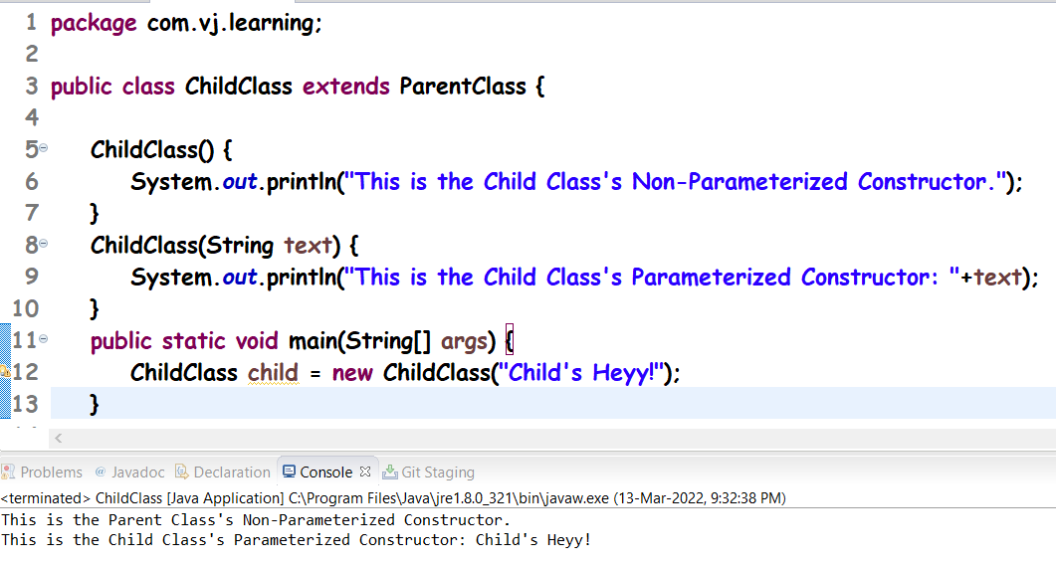

Based on the above image, when we create an object for the Child Class, it can be seen that the constructor (Non Parameterized) of the Parent class is called first and then the constructor (Parameterized) of the Child class is called.

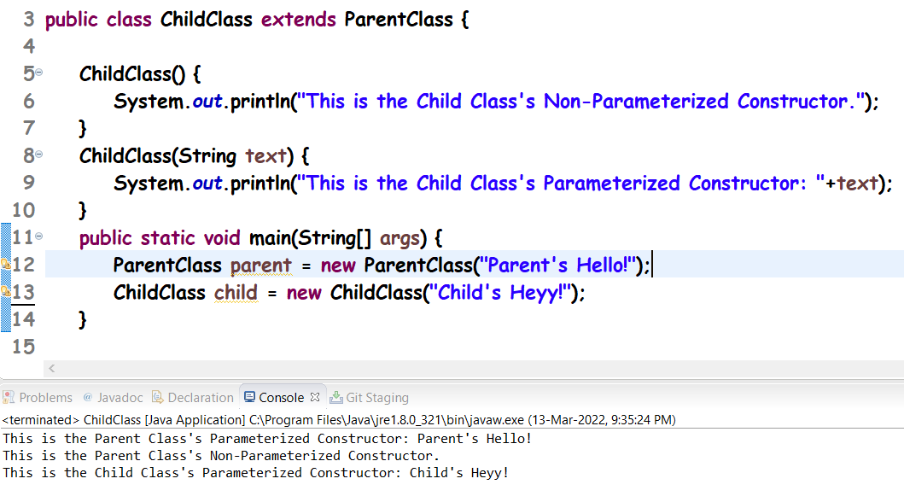

In the above image, we can see that the Parent’s Non Parameterized Constructor was not called first. This is because we have directly called a constructor (The Parameterized one). And then when we called the Child Class’ Parameterized Constructor, the Non Parameterized constructor of the ParentClass was called automatically.

To check multiple conditions (OR scenario), we have to either use if – else if – else if method or Switch Cases.

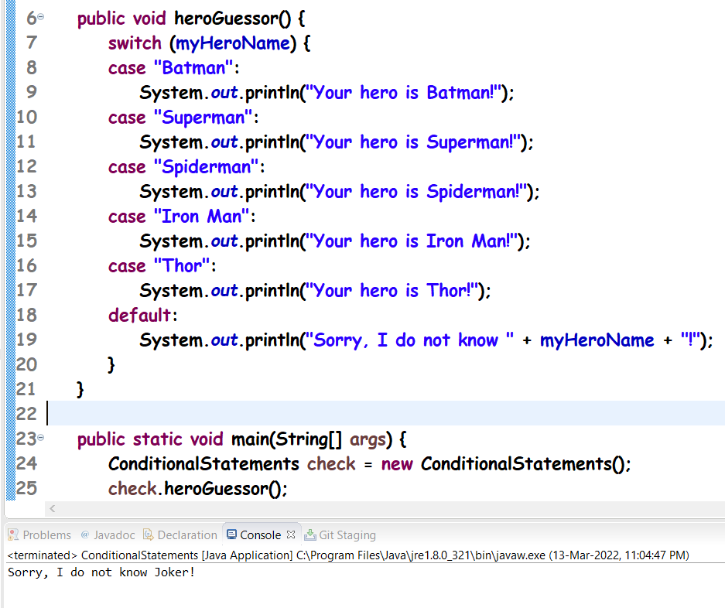

The most important thing about Switch cases:

We need to use break statement. In Switch cases, if there are 10 cases and final default, and our condition matches with the 6th one, then the 6th to 10th and Default (Total of 6 cases) will be executed. If this feature is not necessary, use break everywhere.

